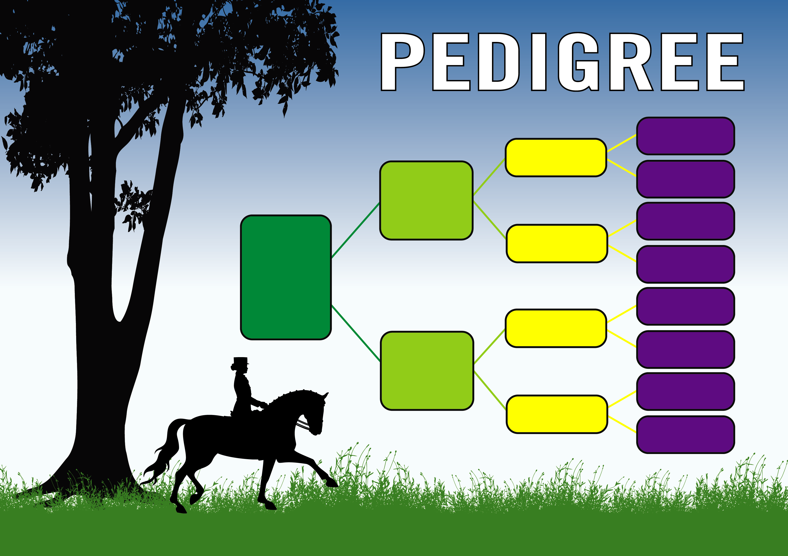

**Worldcup 1**

**(Hanovarian)**

**Anke**

**(Hanovarian)**

**Salute**

**(KWPN)**

**Marengo Maranoa**

**(ArabAnglo)**

**Habitat**

**(USA)**

**Running Ballerina**

**(IRE)**

**Fayyaad**

**(IRE)**

**Nangram**

**(AUS)**

**Weltmeyer**

**(Hanovarian)**

**Salutes**

**Ecstacy**

**(Australian WB)**

**Defecting**

**Dancer**

**(GB)**

**Carasole**

**(AUS)**

**River**

**Range**

**Katherine**

**(AUS)**

**Highhaven Park**

**Welt’s Emperor**

**(Australian**

**Warmblood)**

**River**

**Range**

**Wolverene**