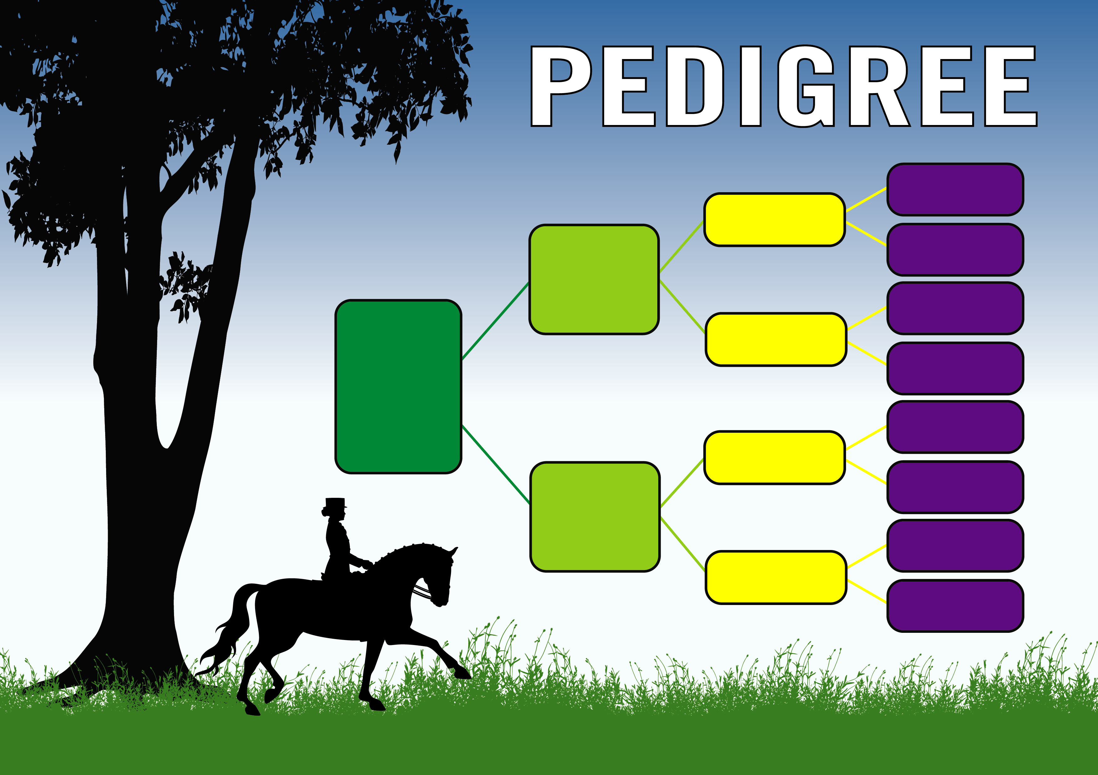
Sandro
Hit

Fantastica

Lander

Holstein Park
Missouri

Sandro
Song

Loretta

Donnerhall

Fiesta

Lorenz

Mametta

Richmead
Medallion

Lorander

Holstein Park Lana
Sunny Boy
Immenhof
Scout

